The undersigned has been appointed as the liquidator for Lanco Infratech Limited (“Corporate Debtor”) vide order dated August 27, 2018 of the National Company Law Tribunal, Hyderabad bench. The undersigned, being the liquidator of the Corporate Debtor, in exercise of his statutory duties has invited expression of interest for assets by issuing public announcement (Annexure ‘A’) which has been published on October 17, 2018 in Financial Express and several regional newspapers.
Pursuant thereto, an expression of Interest (EOI) is invited both in soft copy vide email with subject -“Expression of Interest for participating in liquidation process of Lanco Infratech Limited” to inlancoinfratechip@deloitte.com and vide hardcopy in a plain sealed envelope superscripted as “Expression of Interest for participating in liquidation process of Lanco Infratech Limited”, to submit bids in relation to the liquidation process of the Corporate Debtor, in the format as set out in Annexure ‘B’.
- Bidders should submit the EOI along with the supporting documents set out as Annexure ‘C’
- The details of the applicant should be set out as provided in Annexure ‘D’.
- Bidders who are part of a consortium, should submit undertaking in the manner set out in ‘Annexure E’.
- The sealed envelope containing a complete set of the EOI in hard copy along with the Annexures stated above, to be sent to the following address by post or delivered in person:

Savan Godiawala
Liquidator for Lanco Infratech Limited
Regn.No.:IBBI/IPA-001/IP-P00239/2017-18/10468
Deloitte Touche Tohmatsu India LLP
19th Floor, Shapath - V, S.G.Road, Ahmedabad – 380015]
Email: sgodiawala@deloitte.com
Communication email for EOI: inlancoinfratechip@deloitte.com
Ph: +91 79 6682 7300
Or

Savan Godiawala
Liquidator for Lanco Infratech Limited
Regn.No.:IBBI/IPA-001/IP-P00239/2017-18/10468
Deloitte Touche Tohmatsu India LLP
22nd Floor, Building No. 5, Tower A
DLF Cyber City Phase III, Gurgaon- 122 002, Haryana, India]
Email: sgodiawala@deloitte.com
Communication email for EOI: inlancoinfratechip@deloitte.com
Ph: +91 (124) 679 2000

- EOIs not fulfilling the above conditions are liable to be disqualified without any further communication.

The last date for submission of EOI (both sealed envelope and soft copy) is November 19, 2018 up to 5 pm, which may be extended at the sole discretion of the liquidator of the Corporate Debtor.
In case EOI is not submitted by the specified time period, then the participation can only be allowed if the time period is extended by the liquidator of the Corporate Debtor.
NOTE
- The liquidator of the Corporate Debtor has the right to withdraw the invitation for EOI and change or vary any part thereof at any stage, without assigning any reason and without assigning any liability and also reserves the right to disqualify any potential bidders, should it be so necessary at any stage, at its sole discretion without assigning any reason.
- This is not an offer document and is issued without commitment. Bidders should regularly visit website www.lancogroup.com to keep themselves updated on clarifications/ amendments/ time-extensions, if any.
- No oral conversations or agreements with the liquidator or any official, agent or employee of the liquidator or the Corporate Debtor shall affect or modify any terms of this invitation for EOI.
- Neither the bidder nor any of representatives of the bidder shall have any claims whatsoever against the liquidator or the Corporate Debtor or any of their directors, officials, agents or employees arising out of or relating to this invitation for EOI.
- By submitting an EOI, each bidder shall be deemed to have acknowledged that it has carefully read the entire invitation for EOI and has fully informed itself as to all existing conditions and limitations.
- The liquidator may stipulate the requirement to meet any eligibility criteria.
- All the bidders are required to confirm that they are not ineligible under Section 29A of the Insolvency and Bankruptcy Code, 2016.
- The invitation for EOI & the auction process in the liquidation process of the Corporate Debtor is subject to the provision of the IBC & specifically the rights of the creditors as per Section 52 and 53 of the IBC.
- Bidders will be given access to the data room comprising details of various assets upon signing of Confidentiality Undertaking (Annexure ‘F’).

ANNEXURE A

Public Announcement for Expression of Interest
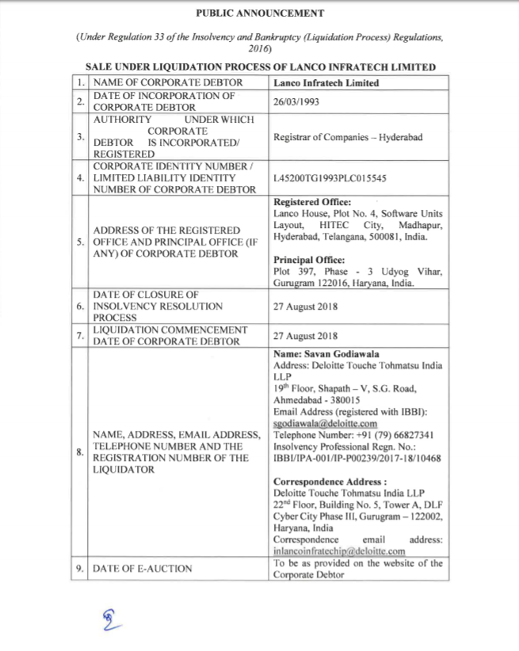
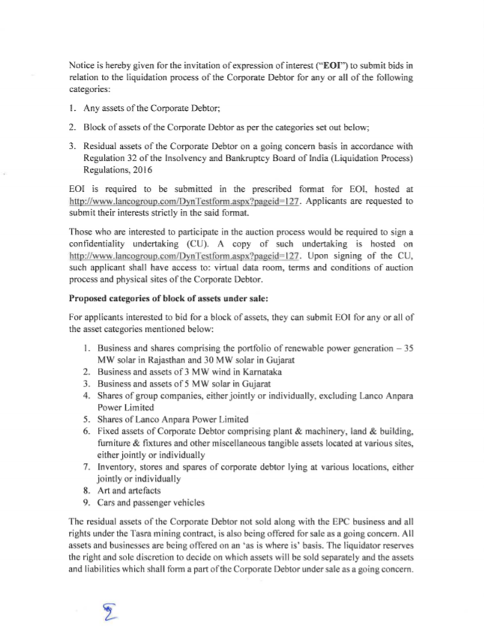
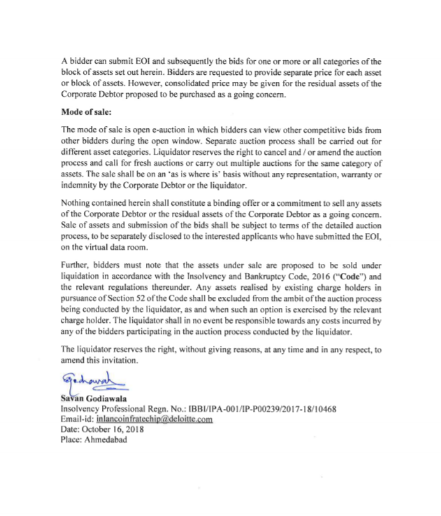
ANNEXURE B
Format of Expression of Interest
[On the letter head of the company/ in case of consortium- the lead member submitting the EOI]
Date;
To,
Savan Godiawala
Liquidator for Lanco Infratech Limited
Regn.No.:IBBI/IPA-001/IP-P00239/2017-18/10468
Deloitte Touche Tohmatsu India LLP
19th Floor, Shapath - V, S.G.Road, Ahmedabad - 380015

Subject: Expression of Interest (“EoI”) for submitting bid for Lanco Infratech Limited (“Corporate Debtor”) undergoing liquidation process.
Dear Sir,
In response to the public announcement in Financial Express on October 17, 2018 and several regional newspapers (“Advertisement”) inviting EOI for the submission of bid for assets / block of assets of the Corporate Debtor undergoing liquidation process as per the provisions of the Insolvency and Bankruptcy Code, 2016 (“IBC”), we submit our EoI for submission of a bid in the liquidation process of the Corporate Debtor.
Along with our EoI, we have also provided information as required in the prescribed format in Annexure B and Annexure C.
We would like to submit our bid for [Asset / block of Asset] as defined in the public announcement dated October 17, 2018.
We further undertake that the information furnished by us in this EoI and Annexures is true, correct, complete, and accurate. Based on this information we understand, you would be able to evaluate our preliminary proposal. Further, we agree and acknowledge that:
- we will submit documents to determine that we are not ineligible under the provisions of the IBC to participate in the liquidation process of the Corporate Debtor;
- liquidator of the Corporate Debtor may reject the EoI submitted by us without assigning any reason/without any liability whatsoever;
- liquidator of the Corporate Debtor reserves the right to request for additional information or clarification(s) from us for the purposes of the EoI and we shall promptly comply with such requirements. Failure to satisfy the queries of the liquidator may lead to rejection of our submission pursuant to EoI;
- Any material adverse change affecting the consortium members’ ability to perform in consortium shall be intimated within three business days to the liquidator;
- In case of consortium, we would comply with the requirement pertaining to equity holding i.e. the lead member must hold at least 51% total equity participation in the consortium who shall be designated as the lead member. All other members would need to have a minimum stake of 24% each in the consortium;
- The invitation for EOI & the auction process in relation to the liquidation process of the Corporate Debtor is subject to the provision of the IBC & specifically the rights of the creditors as per Section 52 and 53 of the IBC.

Yours Sincerely,
On behalf of [Insert the name of the entity submitting the EoI] Signature:
Name of Signatory:
Designation:
Company Seal/Stamp
Note:
- In case of Consortium Bidder the EoI shall be signed by each member.
- The person signing the EoI and other supporting documents should be an authorised signatory supported by necessary board resolutions/authorisation letter.

ANNEXURE C

Supporting Documents to be submitted with EOI

Requirement | Category A  Private/Public Limited Company, LLP, Body Corporate, India | Category B  Financial Institutions (FI)/ Funds / Private Equity (PE) Investors/ NBFC whether incorporated in India or outside /Any other applicant | Category C  Sole Individual investor
1 | Profile of the bidder (As per  Annexure C) | Profile of the bidder (As per  Annexure C) | Profile of the bidder (As per  Annexure C)
2 | Copies of Certificate of  Incorporation/ Registration and Constitutional Documents (MoA, AoA) | Copies of Certificate of Incorporation/ Registration and Constitutional Documents (MoA, AoA) | Government ID proofs including Aadhar card, PAN Card, Voting Card etc.
3 | Audited financial statements for immediately preceding 3  (three) financial years ending on 31 March 2018 | Audited financial statements for immediately preceding 3 (three) financial years ending on 31 March 2018 | Income tax returns for  preceding 3 (three) financial years ending on 31 March 2018
4 | Certificate from Statutory Auditor or Chartered Accountant or Company Secretary or equivalent in the jurisdiction of incorporation of the company certifying total net worth as at end of last 3  financial years ending on 31 March 2018 | Certificate from Statutory Auditor or Chartered Accountant or Company Secretary or equivalent in the jurisdiction of incorporation of the company certifying AUM as at end of last 3 financial years and committed funds at 31 March 2018. | Certificate from Statutory Auditor or Chartered Accountant or Company Secretary or equivalent in the jurisdiction of incorporation of the company certifying net worth as at end of last 3 financial years ending on 31 March 2018
5 | Affidavit in relation to Section 29A eligibility | Affidavit in relation to Section 29A eligibility | Affidavit in relation to Section 29A eligibility

In case of a consortium:
- The above documents including certificates are required for each of the consortium members.
- The relevant documents of the consortium agreement to be also attached.

ANNEXURE D
Details of Potential Bidder
[Note: In case of consortium, the details set out below are to be provided for each of the members]
1. Name and Address:
- Name of the Firm/Company/Organisation/ sole individual:
- Address:
- Telephone No:
- Fax:
- Email:
2. Name and Address (with proof) of the firm/company/organization/sole individual
3. Date of Establishment/ Date of Birth (for sole individual):
4. Overview, corporate structure and core area of expertise and of the firm/company/organization:
5. Contact Person:
- Name:
- Designation:
- Telephone No:
- Email:

6. Company/FI Profile:
- Company Financial Profile (consolidated / standalone as applicable):

Company  profile | Private/Public Limited  Company, LLP, Body  Corporate, | Financial Institutions  (FI)/ Funds / Private  Equity(PE) Investors / NBFC whether  incorporated in India or  outside India/Any  other applicant | Sole Individual investor
At 31 Mar 16 | TNW in Crs | AUM in Crs and  Committed funds in Crs | Net worth in Crs
At 31 Mar 17 | TNW in Crs | AUM in Crs and  Committed funds in Crs | Net worth in Crs
At 31 Mar 18 | TNW in Crs | AUM in Crs and  Committed funds in Crs | Net worth in Crs

7. Assets of interest – interest in each asset / block of assets/ residual assets of the Corporate Debtor on a going concern basis, to be separately mentioned.
8. Rational for interest in the asset/ block of assets/ residual assets of the Corporate Debtor on a going concern basis.

In case of consortium, the above details are to be shared for each of the consortium members.
ANNEXURE E
(To be executed on stamp paper)
To,
[ ]
Dear Sir,
SUBJECT: UNDERTAKING FOR EQUITY PARTICIPATION IN CONSORTIUM
This is in relation to liquidation process of Lanco Infratech Limited. In response to the public advertisement in Financial Express, dated October 17, 2018 and several regional newspapers (“Advertisement”) inviting EOI for the submission of bids in relation to the liquidation process of the Corporate Debtor as per the provisions of the Insolvency and Bankruptcy Code, 2016 (“IBC”), we have submitted an EOI as a consortium. The members of the consortium are as follows:
[Insert names of the members of the consortium and indicate the lead member]
As required in terms of the EOI, we agree and undertake that we will hold at least [insert percentage (lead member to choose [•] and other to choose [•])] equity participation in the consortium. We further agree and undertake that all the members of the consortium shall be jointly and severally responsible for compliance with the terms of the invitation for submission of EOI & bids submitted thereafter.
SIGNED AND DELIVERED by [insert]

ANNEXURE F

[TO BE PRINTED BY THE COUNTER PARTY ON THE STAMP PAPER OF APPROPRIATE AMOUNT AS PER THE STAMP ACT APPLICABLE TO THE STATE OF EXECUTION. COUNTER PARTY IS REQUESTED TO PROCURE THE APPROPRIATE STAMP PAPER]

CONFIDENTIALITY UNDERTAKING

This confidentiality undertaking has been signed by ______________________________________, a potential bidder), having its office at _______________________________________________________ acting through Mr./Ms. ________________________________, the authorized signatory / authorized representative (“Applicant”, which expression shall, unless repugnant to the context, include its successors, legal representatives, permitted assigns and administrators in business) in favour of Mr. Savan Godiawala, an insolvency professional having registration no. IBBI/IPA-001/IP-P00239/2017-18/10468 on ________day of ________________, 2018.

WHEREAS Lanco Infratech Limited, a company registered under Companies, Act, 1956 (thereafter referred as “Corporate Debtor”) is under liquidation process vide NCLT (Hyderabad) order dated August 27, 2018 and Mr. Savan Godiawala having registration no. IBBI/IPA-001/IP-P00239/2017-18/10468 was appointed as the liquidator (“Liquidator”).

WHEREAS the Liquidator is required to share information with a potential bidder after receiving an undertaking from the Applicant to the effect that the Applicant shall maintain confidentiality of the information provided to the Applicant for the purpose of submission of bid for the purchase of the assets of the Corporate Debtor in the liquidation and shall not use such information to cause an undue gain or undue loss to itself or any other person and comply with the provisions of the Code.

THEREFORE, the Applicant hereby declares and undertakes as follows:

- The Applicant declares and undertakes that it will not divulge any information including any financial information of the Corporate Debtor, disclosed to it by the Liquidator (or any other person on behalf of the Liquidator) including but not limited to the asset memorandum, through oral or written communication or through any mode to anyone and the same shall constitute “Confidential Information”. Any information or documents generated or derived by the recipients of Confidential Information that contains, reflects or is derived from any Confidential Information shall also constitute Confidential Information.

- The Applicant further unconditionally and irrevocably undertakes and declares that

- the Confidential Information shall be kept confidential by the Applicant and shall be used solely as allowed under the Code and rules and regulations framed thereunder;
- the Applicant shall not use the Confidential Information to cause any undue gain or undue loss to itself or any other person;
- the Applicant shall comply with all provisions of law for the time being in force relating to confidentiality and insider trading;
- the Applicant shall protect any intellectual property of the Corporate Debtor which it may have access to;
- the Confidential Information may only be disclosed to and shared with any employees or third parties by the Applicant, in accordance with applicable laws, including in relation to confidentiality and insider trading, and terms of this confidentiality undertaking on a strict need-to-know basis and only to the extent necessary for and in relation to the liquidation process of the Corporate Debtor, provided that the Applicant binds such employees and third parties, by way of an undertaking/ agreement, to terms at least as restrictive as those stated in this confidentiality undertaking;
- the Applicant shall ensure that all Confidential Information is kept safe and secure at all times and is protected from any theft or leakage;
- the Applicant shall take all necessary steps to safeguard the privacy and confidentiality of the Confidential Information and shall use its best efforts to secure that no person acting on its behalf divulges or discloses or uses any part of the Confidential Information, including but not limited to the financial position of the Corporate Debtor, all information related to disputes by or against the Corporate Debtor and all the reports and documents prepared by or on behalf of the Liquidator; and
- the Applicant shall be responsible for any breach of obligations under this confidentiality undertaking and shall indemnify the Liquidator for any loss, damages and costs incurred by the Liquidator due to such breach of obligations by the Applicant or any person acting on its behalf.

- Notwithstanding anything to the contrary contained herein, the following information shall however not be construed as Confidential Information
- information which, at the time of disclosure to the Applicant was already in the public domain without violation of any provisions of applicable laws;
- information which, after disclosure to the Applicant becomes publicly available and accessible without violation of applicable laws or a breach of this confidentiality undertaking;
- information which was in the possession of the Applicant prior to its disclosure, as evidenced by the records of the Applicant;
- information that is received by the Applicant from a third party which is not in breach of its confidentiality obligations hereunder; and
- information that is required to be disclosed by the Applicant (and to the extent required to be disclosed) pursuant to the requirements of applicable laws, or order of a judicial, regulatory or administrative authority, provided however the Applicant should use its best endeavours to provide prior intimation of such disclosure to the Liquidator.

- No representation or warranty has been provided by the Liquidator in relation to the authenticity or adequacy of the information provided to the Applicant, including Confidential Information, and the Applicant would not have any claim against the Liquidator or any person acting on its behalf or the Corporate Debtor in relation to any information provided by the Liquidator.

- Nothing in this confidentiality undertaking shall have the effect of limiting or restricting any liability arising as a result of fraud or wilful default.

- Damages may not be an adequate remedy for a breach of this confidentiality undertaking and the Liquidator shall be entitled to the remedies of injunction, specific performance and other equitable relief for a threatened or actual breach of this confidentiality undertaking.

- The Liquidator hereby represents and warrants that it has the requisite power and authority to execute, deliver and perform its obligations under this Agreement.

- The terms of this confidentiality undertaking may be modified or waived only by a separate instrument in writing signed by the Applicant with the prior written consent of the Liquidator that expressly modifies or waives any such term.

- This confidentiality undertaking and any dispute, claim or obligation arising out of or in connection with it shall be governed by and construed in accordance with Indian laws and the courts at New Delhi shall have exclusive jurisdiction over matters arising out of or relating to this confidentiality undertaking.

Signed on behalf of

_________________________________

by Mr____________________

(Name and Designation)
Authorised Signatory

Please insert the category of the bid being submitted. Following are the three categories: - Any assets of the Corporate Debtor; - Block of assets of the Corporate Debtor as per the categories set out in the Advertisment; - Residual assets of the Corporate Debtor on a going concern basis in accordance with Regulation 32 of the Insolvency and Bankruptcy Board of India (Liquidation Process) Regulations, 2016 Further, for the first and section category above, the bidder is required to to mention the name of specific asset/block of assets as given in the public announcement dated October 17, 2018.
Applicable only in case of consortium applicant.
Applicable only in case of consortium applicant.

